**EduNest Project Report**

**Course Title: Advance Web Technology**

**Course Instructor**

**Ms. Sadia Maqbool**

**Submitted by:**

* **Fatima SP22-BCS-025**
* **M Usman Haider SP22-BCS-072**
* **Usman Waris SP22-BCS-072**
* **BCS-7B**

**EduNest**

**Project Description**

EduNest is a modern learning management platform designed to bridge the gap between traditional education and practical development. The system provides a comprehensive environment where instructors can create specialized courses focused on practical skills and industry-relevant knowledge. Students can enroll in these courses to enhance their professional capabilities and gain hands-on experience through structured assignments and projects.

The platform serves as a bridge between education and employment, helping users develop practical skills that are directly applicable in their professional careers. Through its intuitive interface and structured learning paths, EduNest makes skill development accessible, measurable, and effective.

**Scope:**

The scope of the EduNest project includes the development of a web-based learning management system that focuses on practical skill development through instructor-led courses and hands-on assignments. The platform will support core functionalities such as user authentication, role-based access control for students and instructors, course creation and enrollment, task management, and structured task submissions. The backend will be built using Node.js and Express, with MongoDB as the database and Mongoose as the ODM. Middleware components will handle authentication, validation, and error handling to ensure secure and efficient operations. Students will be able to enroll in courses and complete assignments, while instructors will manage course content and track student progress. Features such as live chat, payment integration, and AI-based tools are beyond the scope of this initial version. The project aims to provide a structured, scalable, and practical platform that bridges the gap between education and employable skills.

**System Modules and Components**

**1. Authentication Module**

- Handles user registration and authentication

- Manages JWT token generation and validation

- Implements role-based access control (Student/Instructor)

**2. User Management Module**

- Manages user profiles and information

- Handles user role assignments

- Implements user data validation

**3. Course Management Module**

- Handles course creation and management

- Manages course enrollment

- Handles course content organization

- Implements course access control

**4. Task Management Module**

- Manages course assignments and tasks

- Handles task submissions

- Implements submission tracking

- Manages task deadlines and notifications

**Database Overview**

EduNest uses MongoDB as its database system, with Mongoose as the ODM (Object Data Modeling) library. The database is designed to support a skill-focused learning platform with features for course management, task handling, and user interactions.

**User Schema**

{

  name: String (required),

  email: String (required, unique),

  password: String (required, hashed),

  role: String (enum: ['student', 'instructor']),

  createdAt: Date

}

**Course Schema**

{

  title: String (required),

  description: String (required),

  category: String (required),

  instructor: ObjectId (ref: 'User'),

  students: [ObjectId] (*ref*: 'User'),

  tasks: [ObjectId] (*ref*: 'Task'),

  createdAt: Date,

  updatedAt: Date

}

**Task Schema**

{

  title: String (required),

  description: String (required),

  course: ObjectId (ref: 'Course'),

  dueDate: Date,

  submissions: [{

    student: ObjectId (ref: 'User'),

    content: String,

    submittedAt: Date

  }],

  createdAt: Date

}

**Database Design:**

**REST API Design**

**Authentication Endpoints**

POST /api/auth/register - User registration

POST /api/auth/login - User authentication

**User Management**

GET /api/users/:id - Get user by ID

PUT /api/users/:id - Update user profile

**Course Management**

GET /api/courses - Get all courses

GET /api/courses/:id - Get course by ID

POST /api/courses - Create new course

PUT /api/courses/:id - Update course

POST /api/courses/:id/enroll - Enroll in course

**Task Management**

GET /api/tasks/course/:courseId - Get tasks by course

POST /api/tasks - Create new task

PUT /api/tasks/:id - Update task

POST /api/tasks/:id/submit - Submit assignment

**Screenshot**

**Registration Page:**

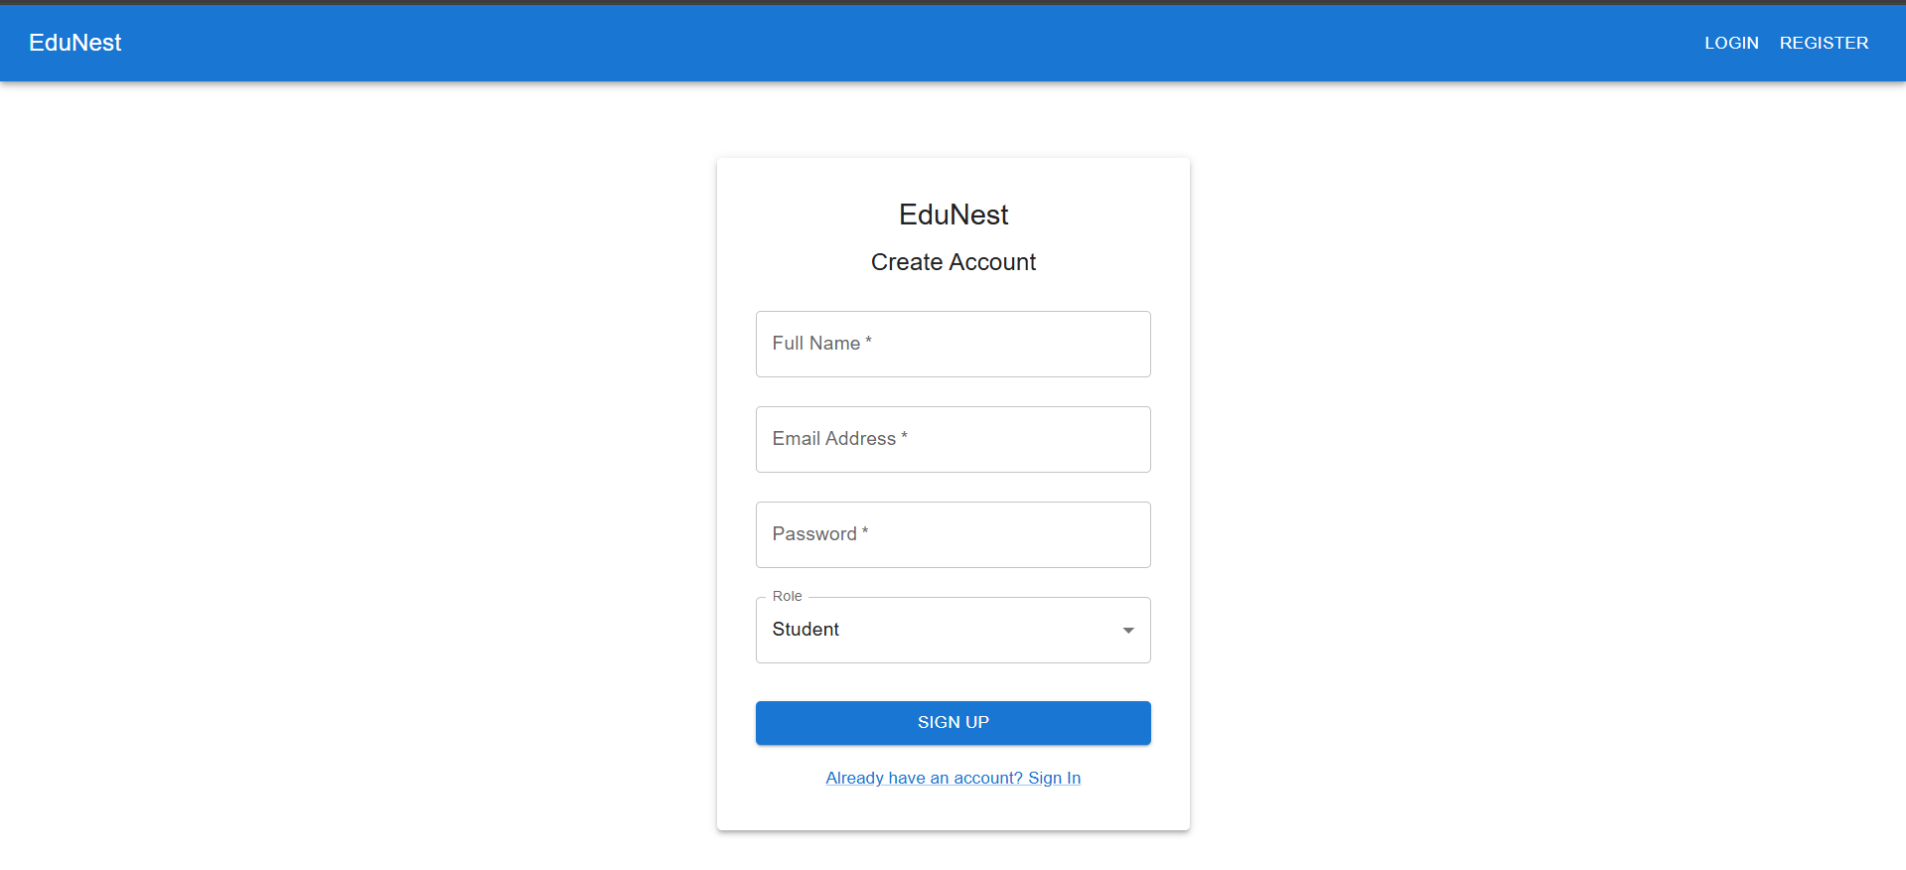

**Login Page:**

**Student Panel:**

**Instructor Panel:**

**Github Link:**

<https://github.com/UsmanHyd/AdvanceWeb-EduNest.git>